**CP Club 365Days Challenge**

**Programming language – C++**

**Problem Statement**

[https://practice.geeksforgeeks.org/problems/leaders-in-an-array-1587115620/1?page=1&difficulty[]=0&sortBy=submissions](https://practice.geeksforgeeks.org/problems/leaders-in-an-array-1587115620/1?page=1&difficulty%5b%5d=0&sortBy=submissions)

**Your Code**:

// 0x57Day of 0x365Days challenge

// VEDANT BHARAD

// 13-12-2022

//{ Driver Code Starts

// C++ program to remove recurring digits from

// a given number

#include <bits/stdc++.h>

using namespace std;

// } Driver Code Ends

class Solution{

    //Function to find the leaders in the array.

    public:

    vector<int> leaders(int a[], int n){

        vector<int> toret;

        int l=a[n-1];

        toret.push_back(l);

        for(int loop=n-2;loop>=0;loop--){

            if(l<=a[loop]){

                l=a[loop];

                toret.push_back(l);

            }

        }

        reverse(toret.begin(), toret.end());

        return toret;

    }

};

//{ Driver Code Starts.

int main()

{

    long long t;

    cin >> t;//testcases

    while (t--)

    {

        long long n;

        cin >> n;//total size of array

        int a[n];

        //inserting elements in the array

        for(long long i =0;i<n;i++){

            cin >> a[i];

        }

        Solution obj;

        //calling leaders() function

        vector<int> v = obj.leaders(a, n);

        //printing elements of the vector

        for(auto it = v.begin();it!=v.end();it++){

            cout << *it << " ";

        }

        cout << endl;

    }

}

// } Driver Code Ends

**Output (Screen Shot)**:

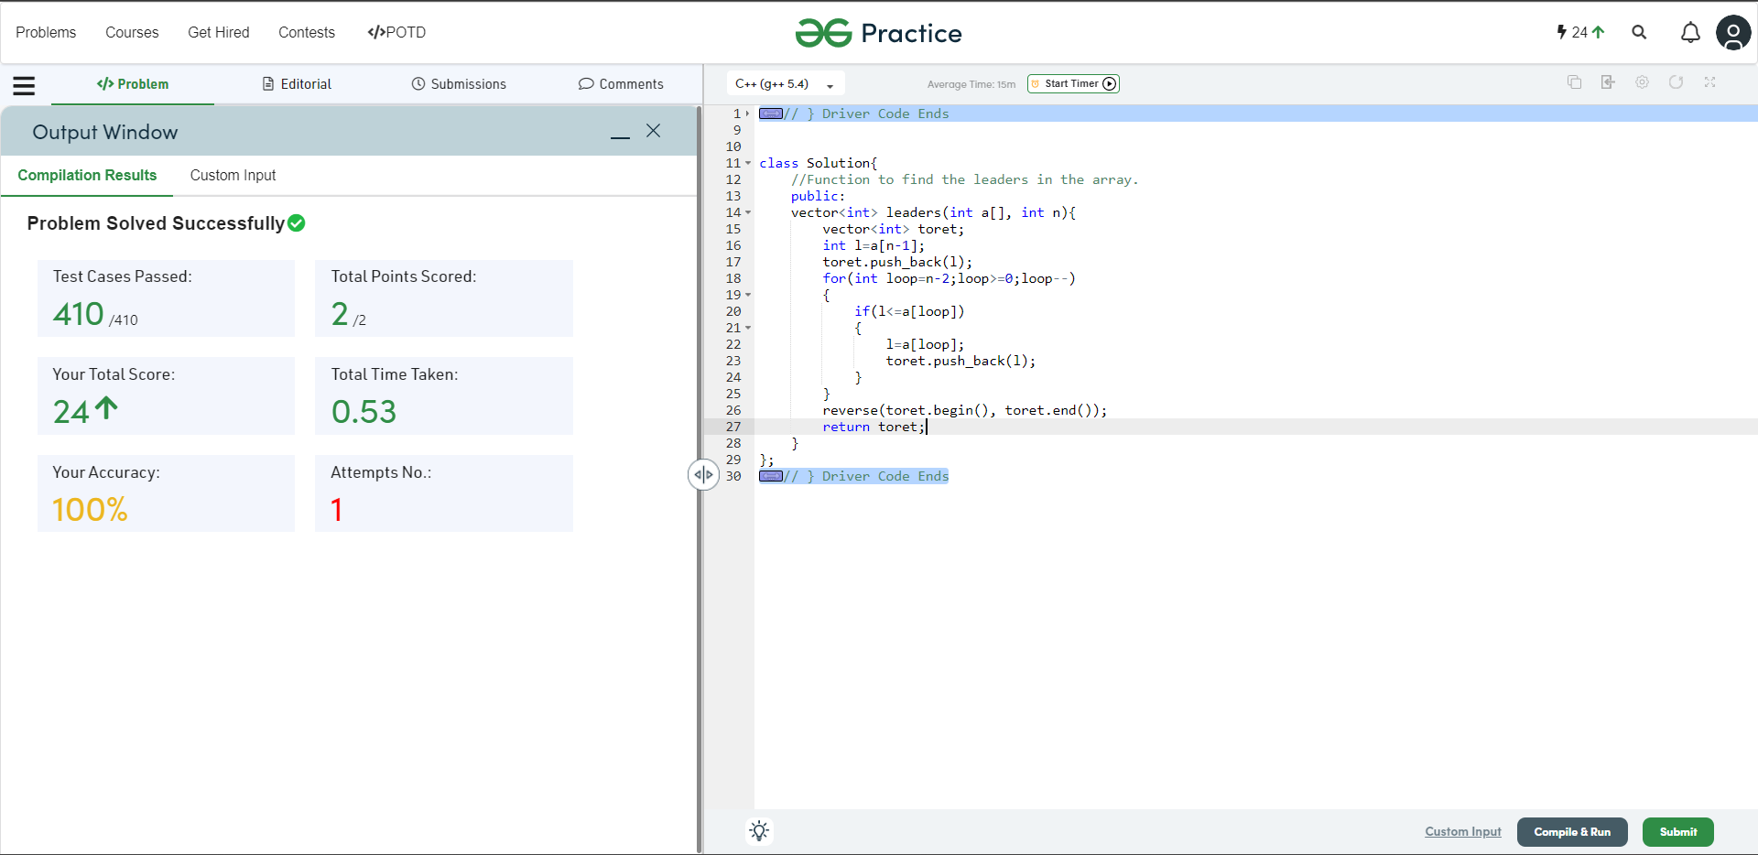

**Understanding about problem:**

* In this task I need to return one int vector in which there are leader number
* For the leader first leader will be right most number and after that for next leader I need to check form last to first in array if the number is greater then or equal to current leader number then next leader will be that number.

Note: If you can't understand the problem, feel free to contact us and we'll help you. Please don't copy and paste from anywhere.

ALL THE BEST

Team CP Club